

The Learning Mentors Newsletter

Hello and welcome to our final newsletter of the year!

As the summer holidays are now almost here, we just wanted to wish you a fantastic break and let you know that we are looking forward to you coming back in September.

We know that this isn’t how we expected the school year to finish but feel rest assured that when you return in September, although things will be a bit different, all the staff at Garfield will be here to support you.

We are still preparing for the changes but want to give you an idea of what will be changing to keep us all safe.

If you have already returned to school, you will know that you have a ‘class bubble’ and you only mix with the children from your ‘bubble’. However, from September, your ‘bubble’ will include your whole year group. There will be a staggered start and end to the day to avoid ‘year group bubbles’ coming into contact with each other. We will also be having staggered break times and lunch times where you will have an area in the playground allocated to your year group. The reason for this is so we can minimise children mixing as much as possible, to keep you safe, and still be able to have all pupils back at school learning.

Your parents/carers will have been sent the Garfield information booklet. Have a look through this as it should answer any questions you may have.

We will still be here for you when you need us, with Miss Longstaff (Sharon) supporting Nursery, Reception, Year 1 & Year 2 and Mrs C walls supporting Years 3 up to Year 6. If you have any worries or concerns, we are always here for you to talk to.

Miss Howard will continue to be in welfare to offer a smile and a plaster etc. should you need one.

To our year 6’s, we want to say good luck and wish you the very best on your journey to secondary school. We hope it is a great experience for you and remember to always believe in yourselves! We have really enjoyed having you at Garfield. You have been brilliant pupils and we will miss you so much. Hopefully you will keep in touch and let us know how you are getting on.

Have a lovely summer holiday, take care and enjoy yourselves,

Sharon and Mrs C Walls

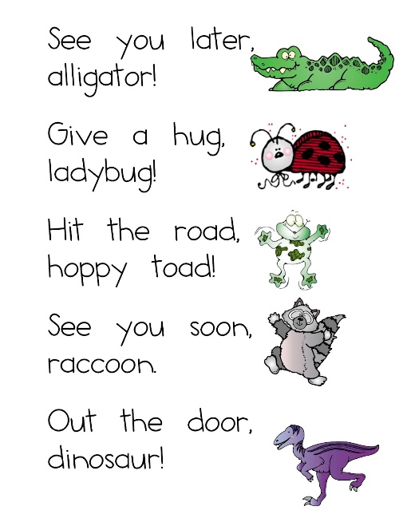

Inspirational Quote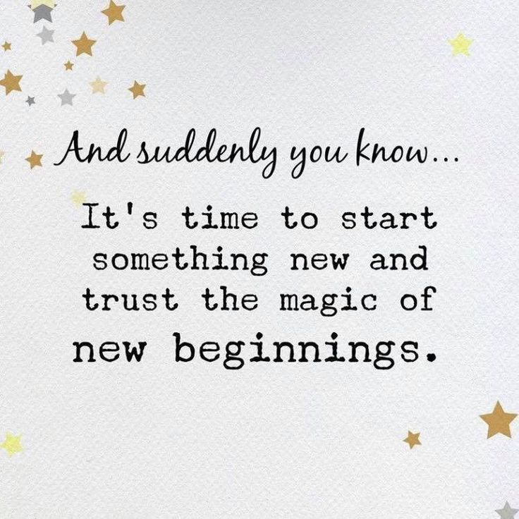



**Yoga**

Shoulder Stand

.

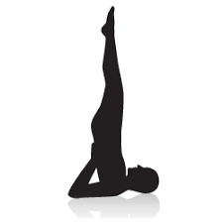

**1.**Lying on your back with the arms alongside the body with the palms down, bend the knees and kick and rock the legs up and back, bringing the bent knees to the forehead and placing the hands under the hips.

**2.** With your hands on your hips, begin to lift the legs up, straightening them over your head. Support the weight of the body with the arms and the shoulders, having very little or no weight in the head and neck.

**3.** Breathe and hold 4-10 breaths.

**4.** To release: bend the knees back to the head, and carefully and slowly roll the spine back onto the floor. Breathe and hold for 2-4 breaths.

Riddle Time

What question can you never answer yes to?

The answer to the riddle in Issue 12 is….

**An egg**

[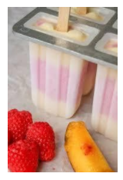](https://www.garfield.enfield.sch.uk/wp-content/uploads/2020/05/Screenshot-2020-05-22-at-9.01.45-AM.png)

**Healthy Ice Lollies**

You will need;

**An adult to help/supervise**

* *Yogurt*
* *Fresh fruit*
* *Ice lolly Mould* (Don’t worry, if you don’t have ice lollies moulds at home you could you use big ice cube trays, clean yoghurt pots, silicone muffin cases or paper/plastic cups.)
* Prepare the fruit (you could use bananas, blueberries, strawberries,

kiwi, pineapple, mango)

* Mix the yoghurt and the fruit together in a bowl
* Pour the mixture into the mould
* Put in the freezer and freeze for at least 2 hours, or until frozen solid
* Run under warm water to help you ease the lolly from the mould
* Delicious on a hot day!

